How to create a purchase order

1. Purchase/Receiving 🡪 Purchase Order
2. Click on “Click here” link

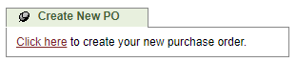

1. Select an office, one vendor and click on “NEXT”

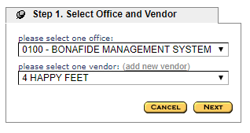

1. Enter all the required data and click on Next

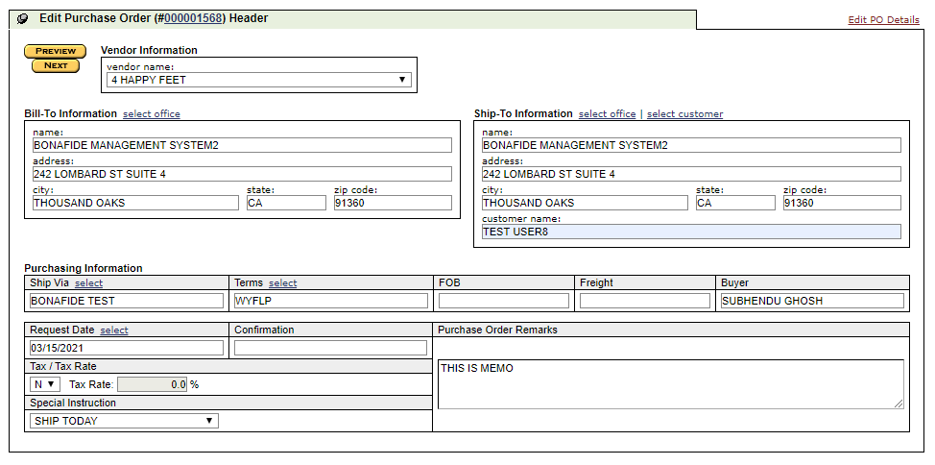

1. Search an item, check the checkcox and click on “Send Selected”

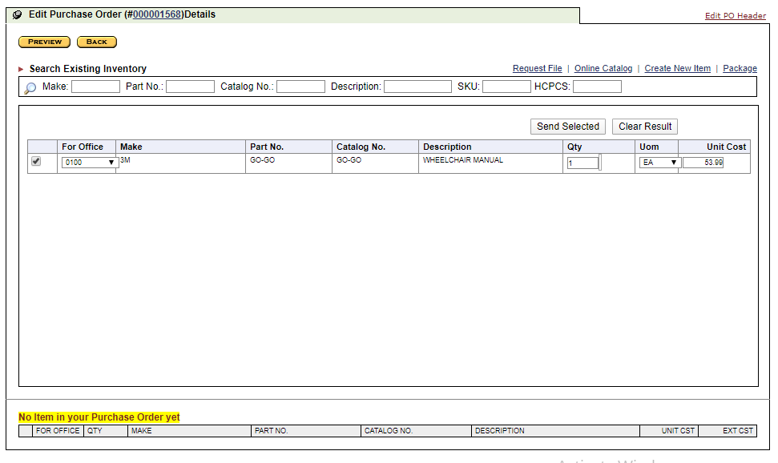

1. Click on “Save and Exit”

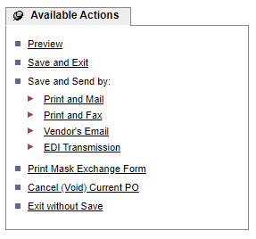

1. You will get a alert message “Your purchase order has been saved successfully”